**The Epidemiological Trends  and Case Analysis of Cholera Outbreaks in Sub-Saharan African Countries (2000 - 2023)**

Adebisi Joy, Aderinto Hassan, Akinmolasere Kadijat ,Elijah Charles Enyi, Robert Jideofor Chukwuanilo, Sodiq Muritala

**Executive Summary**

Cholera remains a critical global health issue, particularly in regions with poor access to clean water and sanitation, such as parts of Africa and Asia. In 2023, there were 324,791 reported cholera cases and 2,181 deaths worldwide. This study focuses on the patterns and trends of cholera outbreaks in Sub-Saharan Africa from 2000 to 2023, where 5,049,667 cases, 4,961,740 recoveries, and 87,927 deaths were reported. Central Africa had the highest burden with 1,963,698 cases and 32,132 deaths, followed by Southern Africa. Significant fluctuations were observed, with notable spikes in 2022 and 2023. Central and Southern Africa accounted for 65.6% of total cases and 59.5% of deaths, with the Democratic Republic of Congo, Nigeria, and Uganda having the highest mortality rates.

Key recommendations include enhancing surveillance systems to improve cholera case monitoring and reporting, improving access to clean water and sanitation to address the root causes, conducting health education campaigns, prioritizing vaccination in high-risk areas, strengthening healthcare systems, and developing robust emergency preparedness and response plans.

In conclusion, the persistent and significant burden of cholera outbreak in Sub-Saharan Africa highlights the urgent need for comprehensive and sustained efforts to combat the disease. By implementing these recommended measures, policymakers, health authorities, and NGOs can work together to reduce the incidence and impact of cholera in the region, ultimately saving lives and improving public health outcomes.

**Keywords:** Cholera, Sub-Saharan Africa, Public Health, Sanitation, Mortality, Health Policy, Water Infrastructure, Outbreaks

**Introduction**

According to the World Health Organization (WHO), cholera causes an estimated 2.9 million cases and 95,000 deaths annually worldwide. It is particularly prevalent in regions with poor access to clean water and inadequate sanitation, especially in parts of Africa and Asia. From January to May 2023, there were 324,791 reported cholera cases and 2,181 deaths globally. Comparatively, the first five months of 2024 saw 200,314 cases and 1,955 deaths, indicating the ongoing severity of cholera outbreaks, particularly in Sub-Saharan Africa. Cholera is caused by the bacterium *Vibrio cholera* which is a severe diarrheal disease. In Sub-Saharan Africa, it remains a major public health issue, worsened by inadequate water, sanitation, and hygiene (WASH) infrastructure. This Cholera Outbreaks in Sub-Saharan African Countries from 2000 to 2023," investigates the patterns and characteristics of cholera outbreaks in the region. Sub-Saharan Africa bears a disproportionate burden of cholera, with thousands of cases reported annually. WHO estimates that cholera affects 1.3 to 6 million people globally each year, causing 21,000 to 143,000 deaths. Large-scale outbreaks in this region lead to significant public health emergencies, high morbidity and mortality rates, and severe economic impacts. This study aims to analyze the epidemiological trends and case characteristics of cholera outbreaks in Sub-Saharan Africa from 2000 to 2023, providing valuable insights to guide public health strategies.

**Methodology**

To comprehensively investigate the epidemiological trends and determinants of cholera outbreaks in Sub-Saharan African countries from 2000 to 2023, a quantitative methods approach was adopted. Below is a detailed outline of the methodology

**Data Collection**

Data was first collected from the World Health Organization (WHO) which the reseachers compiled the data from different source like Our World in Data, Microsoft Copilot, CDC,  and Macrotrends.net compiled into an excel which was later converted to a csv file. Data were gathered on the number of cholera cases reported, deaths and recoveries, countries, years, and population at risk, from the variables above, we determine the recovery rate, case-fatality,  incidence rate, prevalence and risk ratio. R studio was used to clean and arrange the data and named it as cholera dataset and then use for visualization.

**Data Analysis and Result Presentation**

The analysis was carried out using R studio to visualize the cleaned cholera dataset and the following result were obtained:

Table 1.1  The Summary of total reported case, total recovering and total deaths of cholera disease  in sub-Saharan African countries (2000 – 2023)

|  |  |
| --- | --- |
| **Total cases of cholera disease recorded** | **5,049,667** |
| **Total recovered persons** | **4,961,740** |
| **Total deaths from cholera disease** | **87,927** |

Table 1.1 Summarized the reported cases of cholera, the number of persons recovered from the disease and the number of persons that died. From the result, the total number of reported cases  of cholera from 2000 - 2023 is 5,049,667 cases, total number recovered is 4,961,740 persons while the total deaths recorded is 87,927 deaths so far.

Table 1.2  The Summary of Total cases, Recovered, and deaths of Cholera disease by region in sub-Saharan  Africa Countries (2000 – 2023)

|  |  |  |  |
| --- | --- | --- | --- |
| **Regions** | **Total cases** | **Total Recovered** | **Total Death** |
| **Central Africa** | **1,963,698** | **1,934,643** | **32,132** |
| **South Africa** | **1,345,760** | **1,329,281** | **20,196** |
| **East Africa** | **923,679** | **903,483** | **16,478** |
| **West Africa** | **813,454** | **794,333** | **19,121** |

From table 1.2 above, the Central Africa has highest  number of reported cases of cholera, totally 1,963,698, followed by Southern Africa with total

reported cases of 1,345,760. This means that 65.6% of total reported cases of cholera disease in  Sub Saharan Africa comes from Central and Southern Africa. The total number of deaths reported by the Central Africa region is 32132 deaths while the Southern Africa region reported a total of 20,196  deaths. This means that 59.5% of the reported deaths comes from Central and Southern Africa

while the remaining 40.54% deaths come from Western and Eastern Africa. The total number  of recovered persons reported by Central Africa is 193464 (38.95%), Southern Africa is 1329281(26.69%), Western Africa is 794333 while East Africa is 903483. This means that Central Africa and Southern Africa have 65.7% of the recovered persons while the remaining  34.31% is shared among East and West Africa regions.

**Fig 1.1: Pie chart presentation of total cases of Cholera by region in percentage**

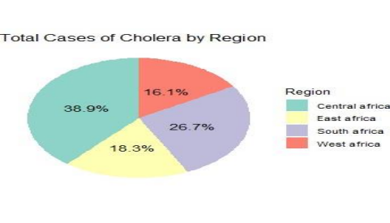

Fig 1.1 shows the piechart presentation of total cholera cases by region, number of the reported deaths and number of recovered persons. From fig 1.1 it can be  deduced that Central Africa region has the highest number of cases of cholera outbreak from 2000 to 2023 with 38.9%, while West  African region has the least number of cholera cases by 16.1%.

**Fig 1.2: Graphical Presentation of Reported Deaths due to Cholera in Sub-Saharan  African by Region**

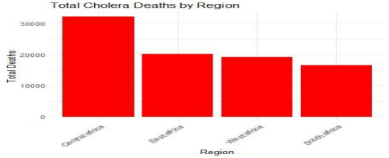

Fig 1.2 shows the graph presentation of total number of reported death cholera cases by region. From fig 1.2, it shows that Central African region has the highest number of reported death from 2000 to 2023 with more than 30,000 cases, while South African region has the least number of death cases with 10,000 plus cases.

**Fig 1.3 Graphical Presentation of Recovered persons from Cholera in Sub-Saharan African by Region:**

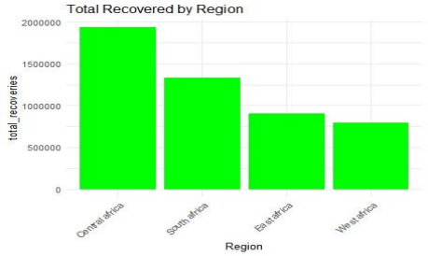

Fig 1.3 shows the graph presentation of total number of recovered cholera cases by region. From fig 1.3 it shows that Central African region has the highest number of reported death from 2000 to 2023 with more than 1,500,000 cases, while West  African region has the least number of recovered cases with 500,000 plus cases.

**Fig 1.4: Graphical Presentation of Reported Cases Of Cholera by Countries In Sub Saharan African (2000-2023)**

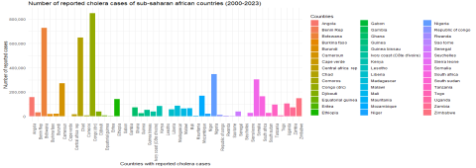

Fig 1.4 shows the number of reported cases of cholera in Sub Saharan Africa African  Countries from 2000 to 2023. From the graph it can be deduce that Democratic Republic of  Congo (Congo Dr), Nigeria, Ethiopia, Angola, Chad, Somalia and Kenya has reported case  of cholera above 300,000 count; while Botswana, Eritrea, Gabon, Lesotho, and Seychelles,  have number of cholera cases below 50,000 count.

**Fig 1.4.1 : Graphical Presentation Showing The Top Ten (10) Highest Reported Cases Of Cholera by Countries In Sub Saharan African (2000-2023)**

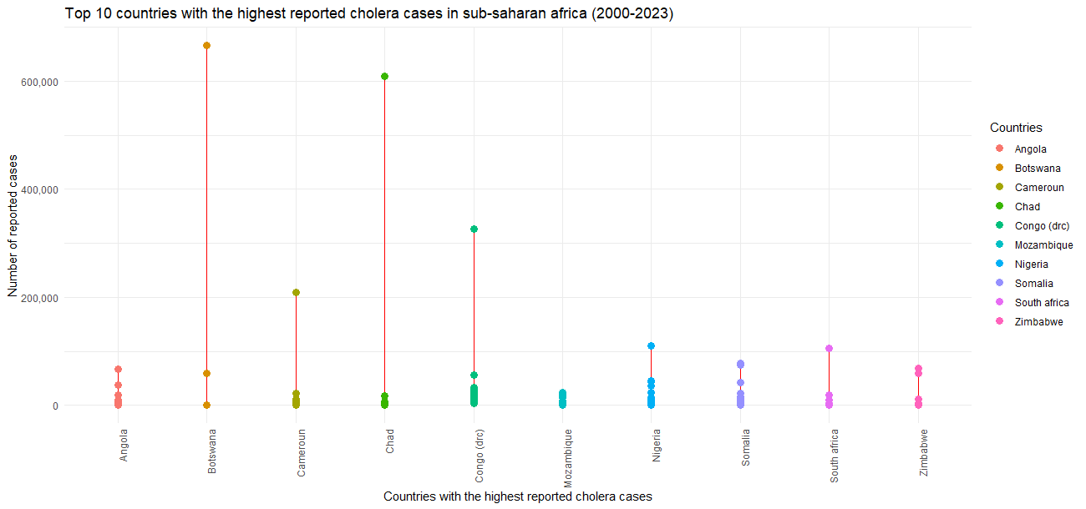

Fig1.4.1 shows the top ten (10) highest number of reported Cholera cases in Sub Saharan African countries from 2000 to 2023. From the graphs it can be deduced that Angola, Botswana,  Chad, Cameroun, Congo DRC, Madagascar, Nigeria,  Somalia, South Africa, and Zimbabwe are the top ten (10) countries with the highest reported Cholera cases and Botswana being the highest country with reported cholera outbreak from 2000-2023.

**Fig 1.4.2 : Graphical Presentation Showing The Top Ten (10) Lowest Reported Cases Of Cholera by Countries In Sub Saharan African (2000-2023)**

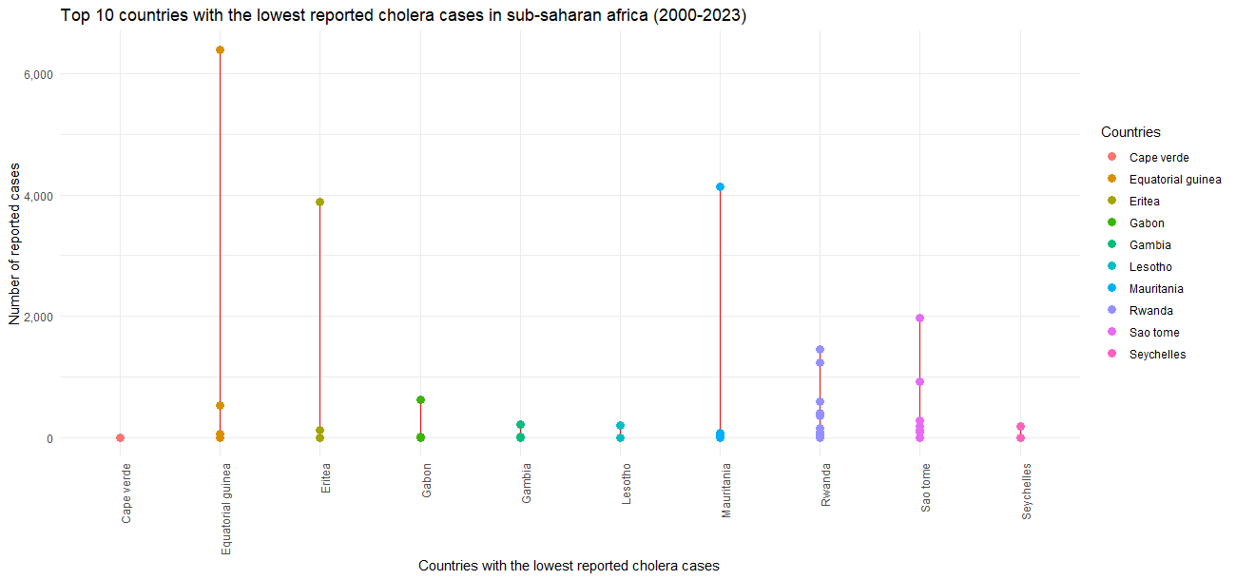

Fig1.4.2 shows the top ten (10) lowest number of reported Cholera cases in Sub Saharan African countries from 2000 to 2023. From the graphs it can be deduced that Cape verde , Equitorial Guinea,  Eritea, Gabon, Gambia, Lesotho, Mauritania, Rwanda, Sao Tome and Seychelles are the top ten (10) countries with  the lowest reported Cholera cases and Cape verde being the least country with reported cholera outbreak from 2000-2023.

**Fig 1.5 Graphical Presentation of Reported Deaths due to Cholera In Sub-Saharan African  by country (2000-2023)**

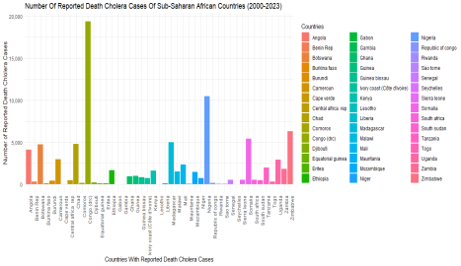

Fig 1.5 shows the number of reported deaths due to cholera in Sub Saharan African countries from  2000 to 2023. From the graph, it can be deduced that Congo Dr, Nigeria and Uganda have  higher reported deaths due to Cholera compared to other Sub Saharan African Countries

**Fig: 1.6: Graphical Presentation of Recovered persons from Cholera In Sub-Saharan  African by Countries:**

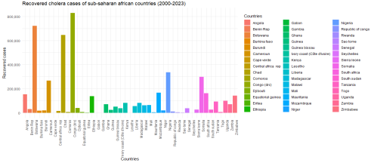

Fig1.6 shows the number of recovered persons from Cholera disease in Sub Saharan African countries from 2000 to 2023. From the graphs it can be deduced that Congo Dr, Botswana,  Chad, Nigeria, Cameroun, Ethiopia, Ghana, Guinea, Kenya, Madagascar, Malawi, Niger,  Sierra Leone, Tanzania, Uganda, and Zambia recorded above 50,000 counts of persons  recovered from Cholera disease.

**Fig: 1.7: Graphical presentation of Top Ten Countries with High Burden of Cholera in Sub Saharan Africa**

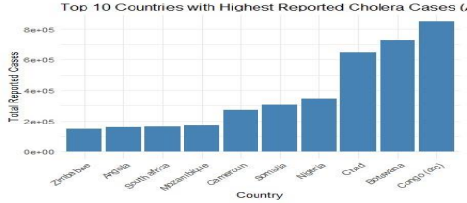

Fig1.7 Shows the ten countries with high reported cases of Cholera from 2000 – 2023. From the  graph it can be deduced that Congo Dr with count above >80,000 has the highest reported  cases of cholera while Zimbabwe with count below <20,000, Has the least reported cases of  cholera from the graph. It is also observed that out of top ten (10) selected countries with high  reported cases of cholera, four (4) Congo Dr, Angola, Cameroon and Chad come from Central Africa.

**Fig 1.8: Trend Analysis Showing Graphical Distribution of Reported cases of Cholera in Sub Africa Countries by Year (2000-2023)**

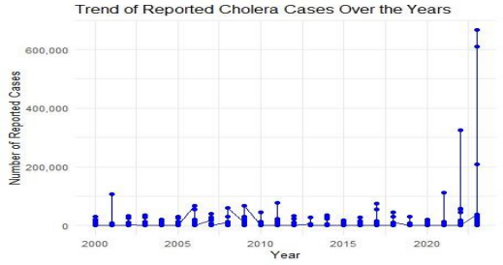

Fig 1.8 Shows the number of reported cholera cases from the year 2000 to 2023. The number of  reported cholera cases shows significant fluctuations over the years, with a notable spike in  reported cases in the most recent years (2022 and 2023). The years 2022 and 2023 show a  sudden rise, with the number of cases reported reaching up to 600,000. This Change be could attributed to the following:

Changes in the spread and virulence of cholera over time, Improvements or changes in disease reporting mechanisms, Natural disasters, climate change, and other environmental  factors contributing to outbreaks, Changes in living conditions, access to clean water, and  sanitation facilities and Introduction of new public health interventions or vaccines in certain  years in the sub region.

**Fig 1.9: Trend Analysis Showing Graphical Distribution of Reported Deaths due to Cholera in Sub Africa  Countries by Year (2000 – 2023)**

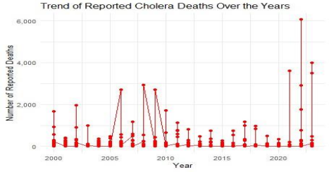

Fig1.9 shows the trend of reported cholera deaths over the years from 2000 to 2023. From the  graph it can be deduced that around 2004, there was a noticeable spike in reported deaths, reaching  just below 2,000. Between 2007 and 2010, there were several noticeable increases, with the  highest reaching over 4,000 deaths around 2009-2010. At post-2020, there is a significant rise in  reported deaths, with a peak reaching around 6,000. The most significant increases in reported  deaths occur post-2020, indicating a severe rise in cholera outbreaks or improved  reporting/recording mechanisms during these years. The data points show significant changes  year over year, suggesting outbreaks may be influenced by episodic factors such as seasonal  changes, specific interventions. The spikes might correlate with specific cholera outbreaks, indicating the need for targeted public health interventions during these periods. The significant  increase between 2020 to 2023 necessitates urgent public health response and implementation  of effective control mechanisms.

**Fig 2.0: Graphical Distribution of case-fatality rate(CFR) in Sub-Saharan Africa  Countries by Year (2000 – 2023)**

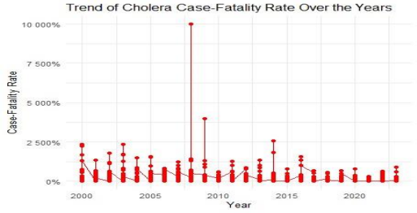

Fig 2.0 Shows the trend of the cholera case-fatality rate over the years from 2000 to 2023. The  red dot represents the case-fatality rate for a specific year while the trend line connecting these  data points, shows the overall trend over time. The case-fatality rate appears to fluctuate  significantly from year to year, with an exceptionally high spike in 2010, where the case-fatality  rate reached almost 10,000%. After the spike in 2010, the rates seem to be relatively lower and  more stable with fewer sudden increases. The discussion about the graph is as follows:

**2010 Sudden Increase**: The spike in 2010 could be attributed to a significant cholera  outbreak, possibly influenced by factors such as natural disasters, which led to an  overwhelming number of cases and a higher mortality rate due to strained healthcare  resources.

**Data Quality and Reporting**: The variation and spikes in the case-fatality rates could  also be influenced by differences in reporting standards, data collection methods, and  healthcare infrastructure across different years and regions.

**Public Health Interventions** The relative stability and lower rates post-2010 might  indicate improvements in public health interventions, better access to medical care, and  more effective cholera management and prevention strategies.

**Fig.2.1: Map Presentation of Incidence Rate of Cholera in Sub Saharan Africa**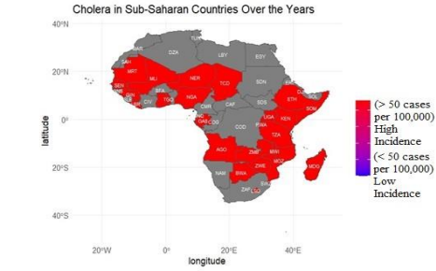

Fig 2.1 displays the incidence of cholera in Sub-Saharan African countries over the years. The  color coding differentiates between high and low incidence rates**:**

• **Red color** represents countries with a high incidence of cholera, defined as more than 50  cases per 100,000 people.

• **Gray color** represents countries with a low incidence of cholera, defined as less than 50  cases per 100,000 people.

**Result Discussion**

### Result Discussion

The World Health Organization (WHO) reports that globally, there are 6 million cholera cases and 143,000 deaths. Sub-Saharan Africa contributes significantly, with 84% of cases and 61% of deaths. From 2000 to 2023, Sub-Saharan Africa reported 5,049,667 cholera cases, with 4,961,740 recoveries and 87,927 deaths. Central Africa and Southern Africa account for 65.6% of the cases and 59.5% of the deaths in this region, while also having 65.7% of the recoveries. In Central Africa, 1,963,698 cases and 32,132 deaths were reported, and Southern Africa reported 1,345,760 cases and 20,196 deaths. Eastern and Western Africa shared the remaining cases and deaths. The top ten highest number of reported cholera cases in Sub-Saharan African countries from 2000 to 2023. From the graphs, it can be deduced that Angola, Botswana, Chad, Cameroun, Congo DRC, Madagascar, Nigeria, Somalia, South Africa, and Zimbabwe are the top ten countries with the highest reported cholera cases, with Botswana being the highest country with reported cholera outbreaks during this period. The top ten lowest number of reported cholera cases in Sub-Saharan African countries from 2000 to 2023. From the graphs, it can be deduced that Cape Verde, Equatorial Guinea, Eritrea, Gabon, Gambia, Lesotho, Mauritania, Rwanda, Sao Tome, and Seychelles are the top ten countries with the lowest reported cholera cases, with Cape Verde being the least affected country during this period.

Cholera cases are concentrated in countries like the Democratic Republic of Congo, Nigeria, Ethiopia, and Kenya, with over 300,000 cases each. Deaths are highest in Congo, Nigeria, and Uganda. Recovery counts are also high in Congo, Nigeria, and other countries with over 50,000 recovered individuals each. Trends show fluctuations in cholera cases from 2000 to 2023, with significant spikes in 2022 and 2023, reaching up to 600,000 cases. Factors include changes in disease spread, reporting mechanisms, natural disasters, and public health interventions. Cholera deaths peaked around 2009-2010 and post-2020, suggesting severe outbreaks or improved reporting. The case-fatality rate spiked significantly in 2010, possibly due to a major outbreak, then stabilized with improvements in healthcare.

A map shows high cholera incidence in West, Central, East, and parts of Southern Africa, with better control in North and some Southern African countries. High-incidence areas struggle with healthcare infrastructure and sanitation, requiring better resources for interventions like vaccination and sanitation improvements. Enhanced surveillance and research are crucial for early detection and targeted public health measures.

**Conclusion**

This study underscores the persistent challenge of cholera in Sub-Saharan Africa, highlighting the urgent need for improved water, sanitation, and hygiene (WASH) infrastructure, enhanced surveillance, and effective public health interventions. The analysis of data from 2000 to 2023 reveals significant regional disparities, with Central and Southern Africa experiencing the highest burden. The map highlights significant disparities in cholera incidence across Sub-Saharan Africa countries, emphasizing the need for targeted public health interventions and improved infrastructure to combat this persistent health challenge. Efforts should focus on high-incidence areas with comprehensive strategies to prevent and control cholera outbreaks effectively.

**Recommendations**

Based on epidemiological trends and case analysis of cholera outbreaks in sub-saharan Africa, in order to combat cholera effectively, several key strategies should be implemented:

**Enhanced Surveillance and Reporting:** Strengthen national and regional systems for timely and accurate cholera case reporting, using standardized definitions and protocols to ensure data consistency.

**Access to Clean Water and Sanitation:** Invest in WASH infrastructure in high-case countries like Nigeria, Angola, and the DRC. Promote community-based water treatment and safe storage to reduce transmission risk.

**Health Education and Community Engagement:** Launch health education campaigns to inform about cholera transmission, symptoms, and prevention. Engage local leaders and organizations to support behavior change and safe hygiene practices.

**Vaccination Campaigns:** Prioritize oral cholera vaccines (OCV) in high-risk areas and during outbreaks, integrating with other public health initiatives for greater impact.

**Strengthening Healthcare Systems:** Enhance healthcare facilities' capacity to diagnose and treat cholera, ensuring the availability of essential supplies and training healthcare workers in cholera management and infection control.

**Emergency Preparedness and Response:** Develop national cholera preparedness and response plans, including pre-positioning supplies and establishing rapid response teams. Conduct regular simulations to ensure outbreak readiness.

**Monitoring and Evaluation:** Implement mechanisms for ongoing monitoring and evaluation of cholera control programs to assess effectiveness and share best practices across countries.

**Targeted Interventions in High-Risk Areas:** Focus resources on high-case countries to address severe outbreaks and improve recovery rates, while maintaining low incidence in low-case countries to prevent outbreaks.

**References**

[**https://macrotrends.net/**](https://macrotrends.net/)

[**https://ourworldindata.org/**](https://ourworldindata.org/)